|  |
| --- |
|  |
|  |

**BAKERY STORE ONLINE**

Report #6 – User Guide

|  |  |  |
| --- | --- | --- |
| **Bakery Store Online** | | |
| **Group Members** | Cao Anh Tuấn | SE03737 |
| Phạm Thị Minh Phương | SE03773 |
| Nguyễn Xuân Hà | SE03484 |
| Ngô Trung Kiên | SE03736 |
| Hoàng Anh Phương | SE03715 |
| **Supervisor** | Mr. Nguyễn Văn Sang | |
| **Project code** | BSO | |

**- Hanoi, 12/2017 -**

# SIGNATURE PAGE

AUTHOR: Cao Anh Tuấn 07/12/2017

Team member

REVIEWERS: Phạm Thị Minh Phương 12/12/2017

Project manager

APPROVAL: Nguyễn Văn Sang --/--/--17

Supervisor

Record of change

*A - Added M - Modified D – Deleted

|  |  |  |  |  |  |
| --- | --- | --- | --- | --- | --- |
| Effective Date | Changed Item | A,M,D | Change Description | Reason for Change | Rev. Number |
| 07/Dec/2017 | User installation | A | Add new |  | 1.0 |
| 10/Dec/2017 | User guide | A | Add new |  | 1.0 |
|  |  |  |  |  |  |
|  |  |  |  |  |  |
|  |  |  |  |  |  |
|  |  |  |  |  |  |
|  |  |  |  |  |  |
|  |  |  |  |  |  |
|  |  |  |  |  |  |
|  |  |  |  |  |  |
|  |  |  |  |  |  |
|  |  |  |  |  |  |
|  |  |  |  |  |  |
|  |  |  |  |  |  |
|  |  |  |  |  |  |
|  |  |  |  |  |  |
|  |  |  |  |  |  |

Contents

SIGNATURE PAGE 1

1 Introduction 3

2 USER GUIDELINES 3

2.1 User 3

2.1.1 Sign up 3

2.1.2 Sign up 4

2.1.3 Buy Cakes 5

2.1.4 Profile 6

2.1.5 Event 9

2.1.6 Blog 10

2.2 ADMIN 12

2.2.1 Login 12

2.2.2 Dashboard 13

2.2.3 Users 14

2.2.4 Projects 15

2.2.5 Backing 15

2.2.6 Category 16

2.2.7 Slider 16

2.2.8 Message (same as message of user) 17

2.2.9 Report 18

# Introduction

This user's manual has been developed to help users better understand the requirements that may apply to use this website by providing them simple step by step tutorials. This manual is intended to help make website's functions more accessible and their associated requirements more understandable to users.

# USER GUIDELINES

## User

### Sign up

This is the first page which user will see. From this page the user can go to every page they want.

To register account on website, the users do the steps below:

Step 1: Open browser and enter to the address bar: <http://catbakery.herokuapp.com/>. Homepage is displayed.

Step 2: Click on Sign in button in header. Users will go to Sign in page.

Step 3: Click Sign up on Sign in page. Users will move to Sign up page.

Step 4: Enter information and click on Sign up to register.

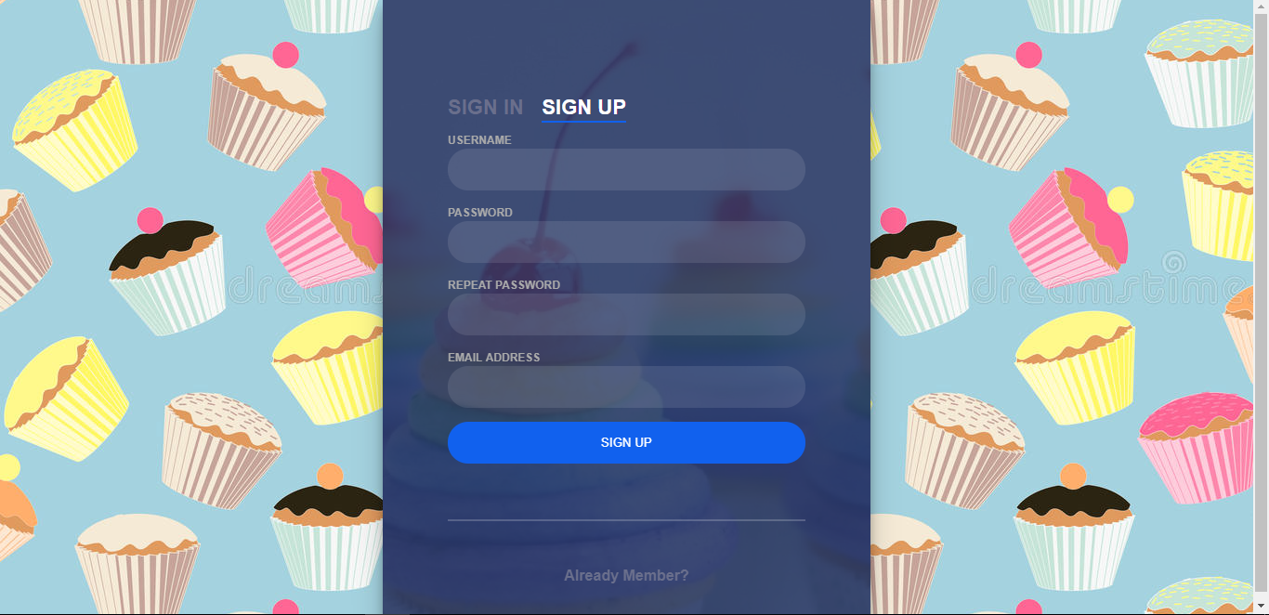

1. Sign up **screen**

### Sign up

To login account on website, the users do the steps below:

Step 1: Open browser and enter to the address bar: <http://catbakery.herokuapp.com/>. Homepage is displayed.

Step 2: Click on Sign in button in header. User will go to Login page.

Step 3: User can Login with BSO’account:

Step 3.1: User enter username and password

Step 3.2: Click on Login button

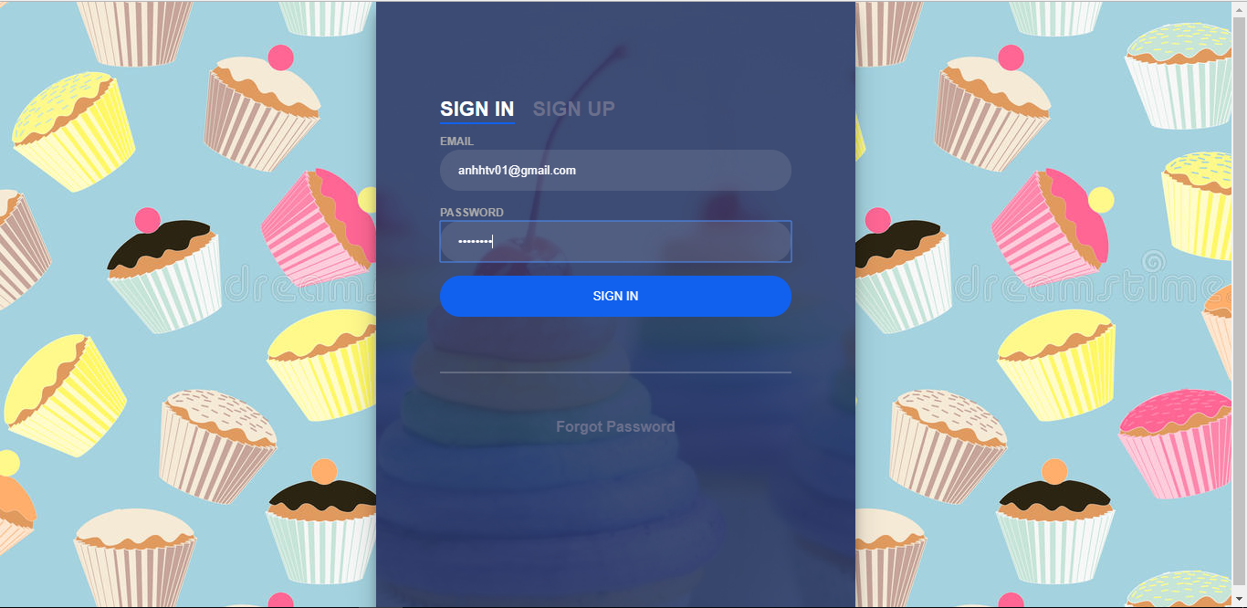

1. Login **page**

### Buy Cakes

To buy a cake on website, the users do the steps below:

Step 1: In Home page user will see list of cake.

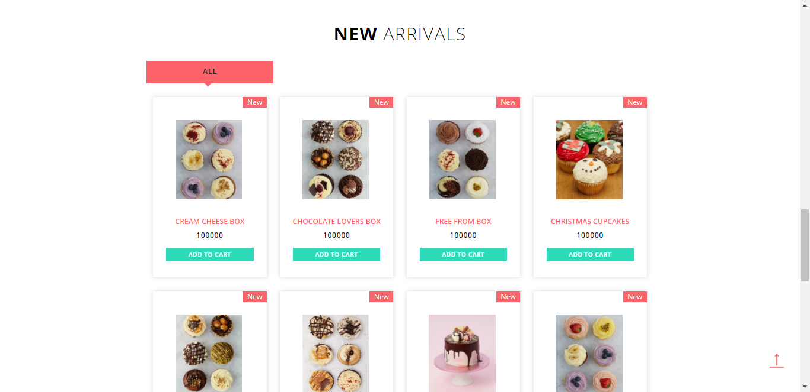

**Figure 2-3: List cake**

Step 2: Click on add to cart to add cake to your cart.

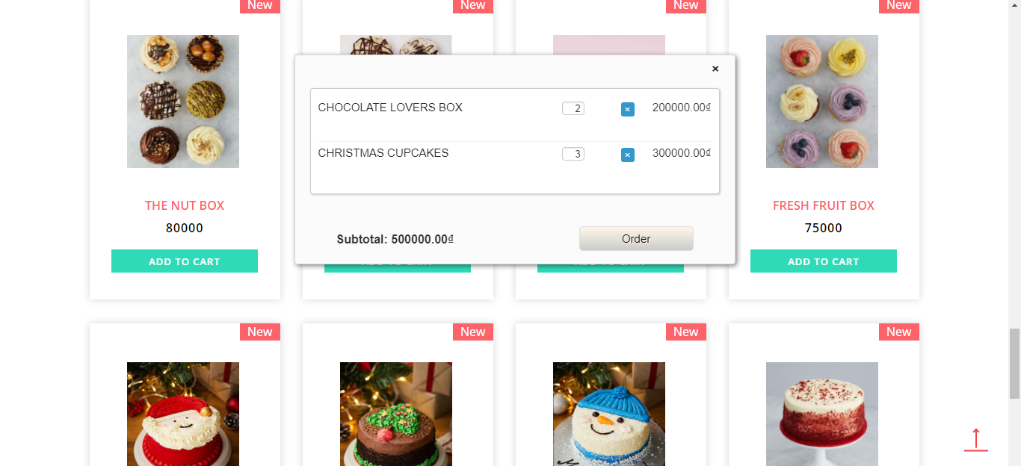

**Figure 2-4: Oder cake**

Step3: Click order to view your order

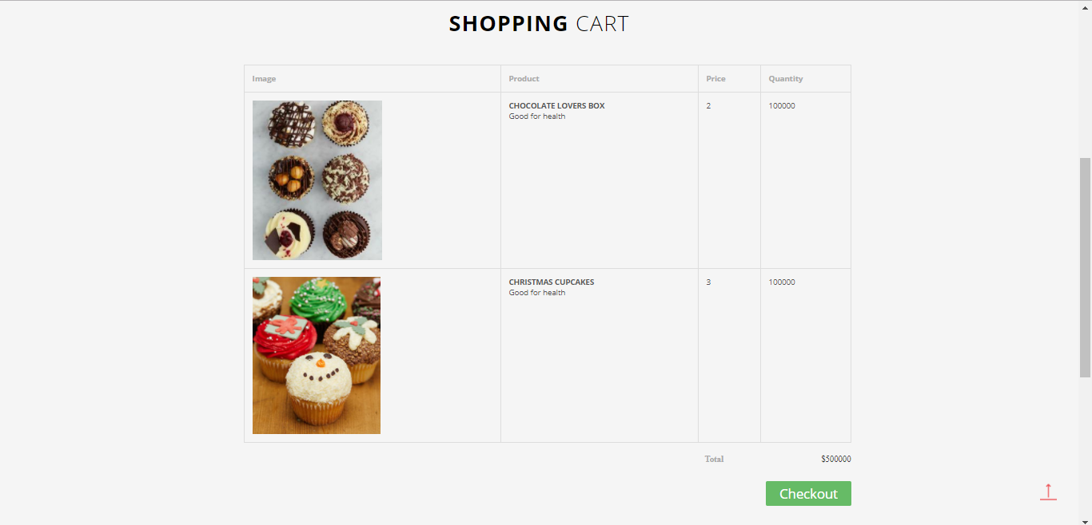

**Figure 2-5: Check out**

Step4: Click check out to finish your oder

If your don’t have an acount you need to fill this form to finish your order

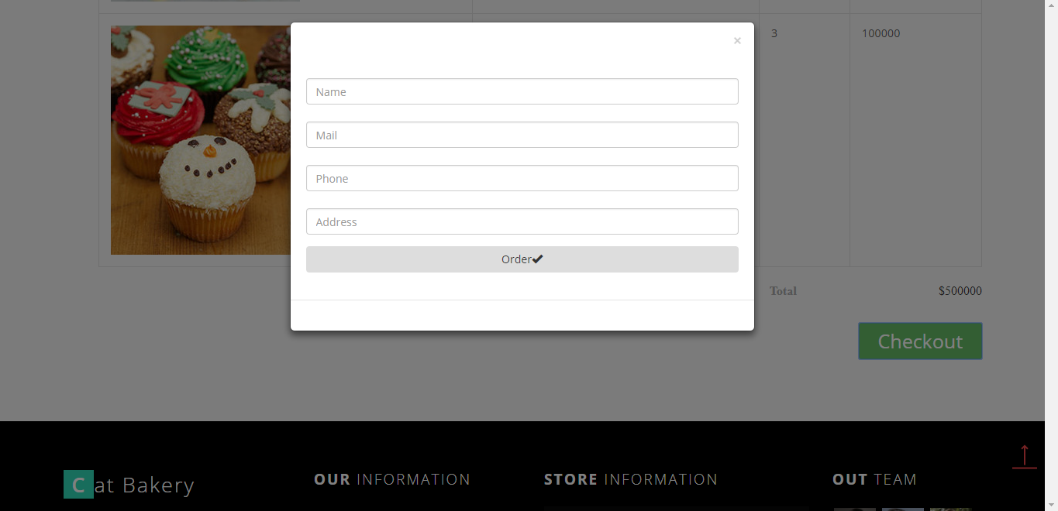

**Figure 2-6: Finish order**

If you have an acount your order will be success.

### Profile

When you loggin to the page with BOS’account.

In this page, user can view, edit profile, change password, view purchase history, the user do the steps below:

Step 1: Go to Homepage.

Step 2: Click on your name in the top left corner

Step 3: You will see the popup then click to the Profile button. User will go to Profile page

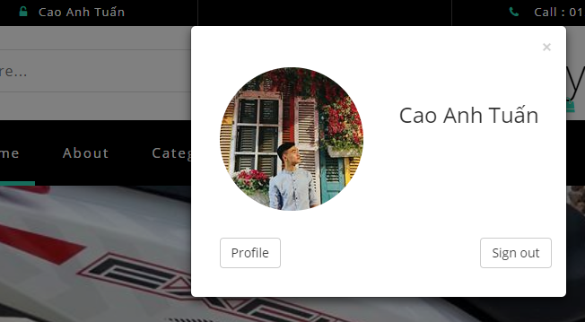

**Figure 2-7: Go to Profile Page**

#### View and Edit Profile

In this page, user can view and edit profile, the user do the steps below:

Step 1: Click to Account Information.

Step 2: User can change any item in account information.

Step 3: User click update to update profile

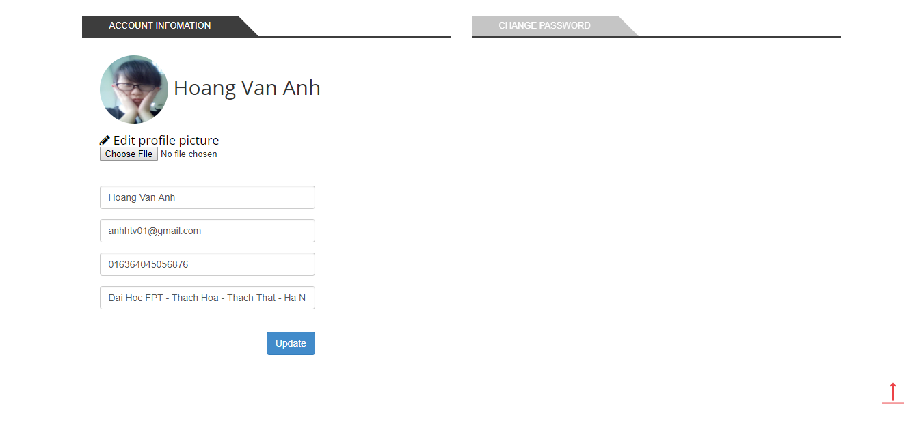

**Figure 2-8: Account Infomation**

#### Change Password

In this page, user can change account password , the user do the steps below:

Step 1: Click to Change Password.

Step 2: User type curent password then type new password và confirm new password

Step 3: Click on Change to chage your password.

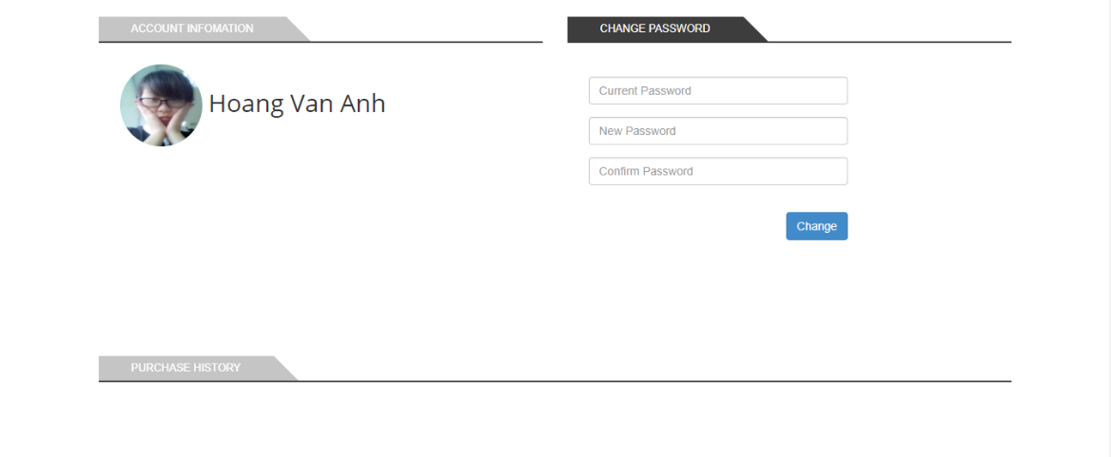

**Figure 2-9: Change Password**

#### Purchase History

In this page, user can view purchase history, the user do the steps below:

Step 1: Click to Purchase History.

Step 2: User can view all the has bought.

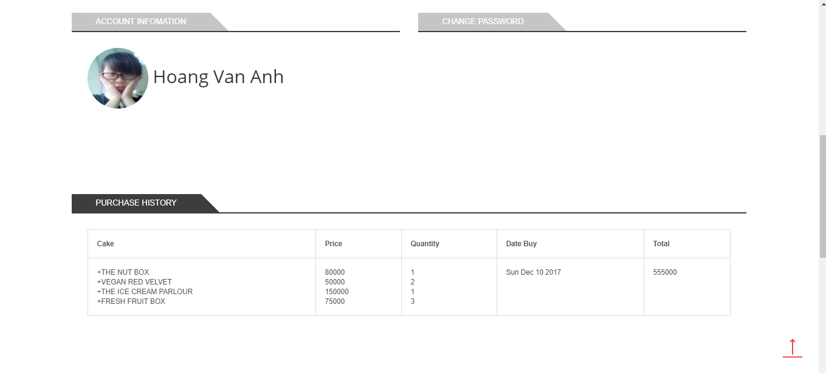

**Figure 2-10: Purchase History**

### Event

In Homepage User can see slide event.

User can view detail event, the user do the steps below:

Step 1: Click on the image of the event in slide on screen



**Figure 2-11: Slide event**

Step 2: Users will go to Event detail page.



**Figure 2-12: Detail Event**

### Blog

User can view blog, the user do the steps below:

Step 1: Click on the blog button on menu bar

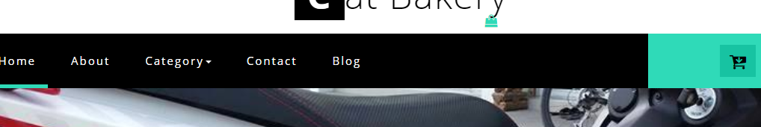

**Figure 2-13: Menu Bar**

Step 2: User will go to the Blog page



**Figure 2-14: Blog page**

Step 3: User can view detail of blog by click to the button Read more

Step 4: User will go to Detail Blog page

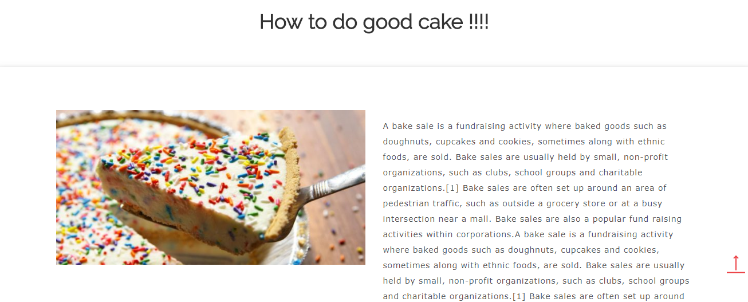

**Figure 2-15: Blog detail page**

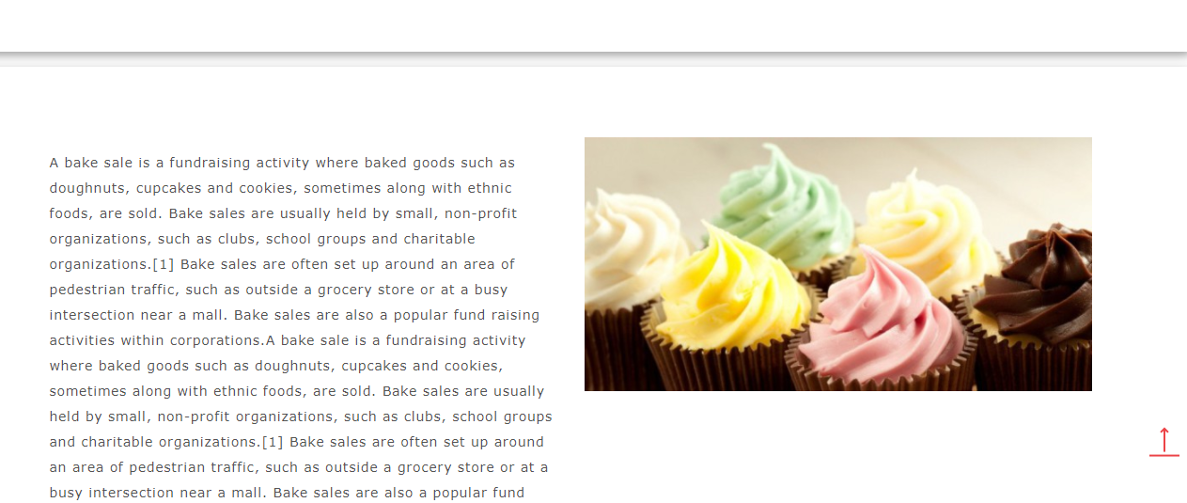

**Figure 2-16: Blog detail page**

## ADMIN

### Sign in

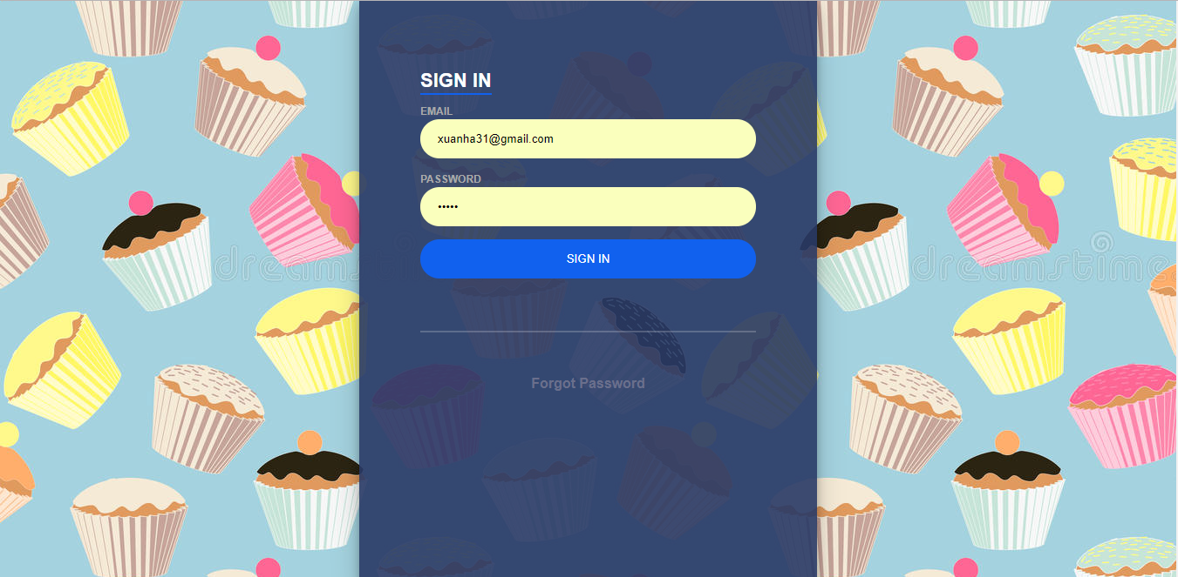

**Figure 2-17: Sign in Screen**

To login admin account, the users do the steps below:

Step 1: Open browser and enter to the address bar: <http://catbakery.herokuapp.com/loginAD/>.

Step 2: User enter username and password

Step 3: Click on Sign in button

### Forgot Password

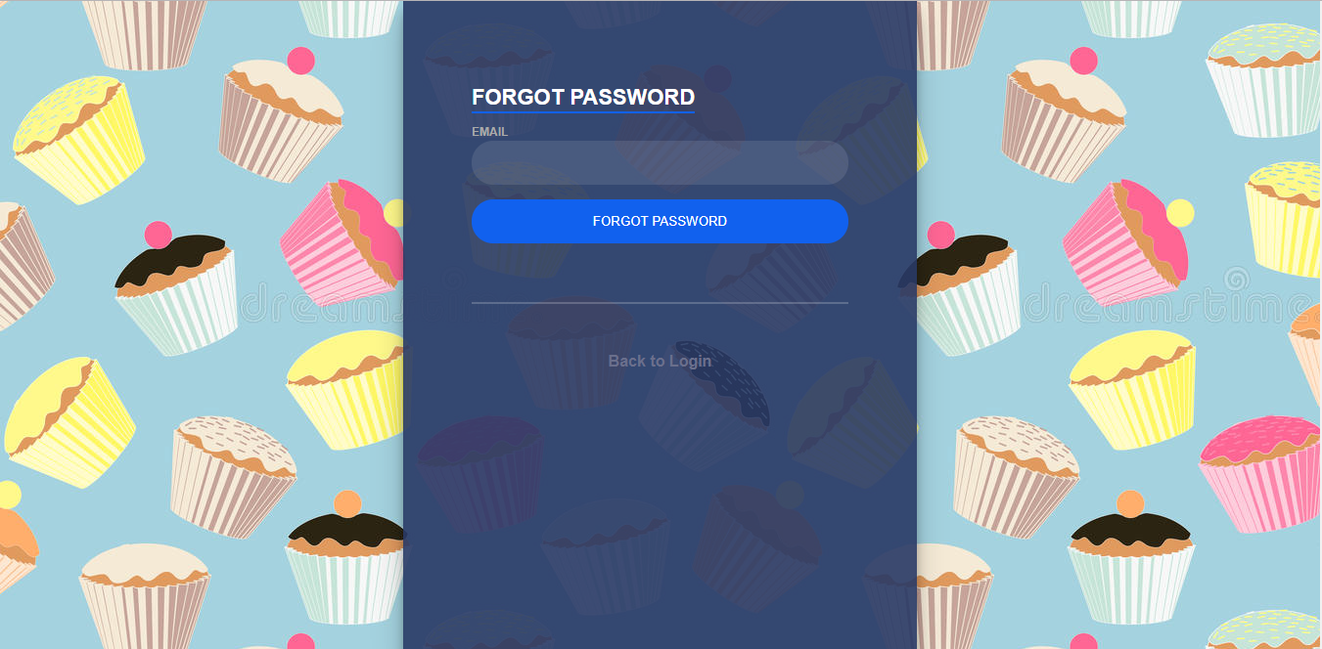

**Figure 2-18: Forgot password Screen**

If forgot password , the users do the steps below:

Step 1: Open browser and enter to the address bar: <http://catbakery.herokuapp.com/loginAD/>.

Step 2: Click to the Forgot password button below sign in button.

Step 3: Enter the email of admin

Step 4: System will sent to your mail a new password with random character

### Change password

To change admin account password, the users do the steps below:

Step 1: Click admin on the top right corner then select change password. User will go to change password page

Step 2: User enter old password then enter new password and confirm password

Step 3: Click on change to change password or cancel to cancel.

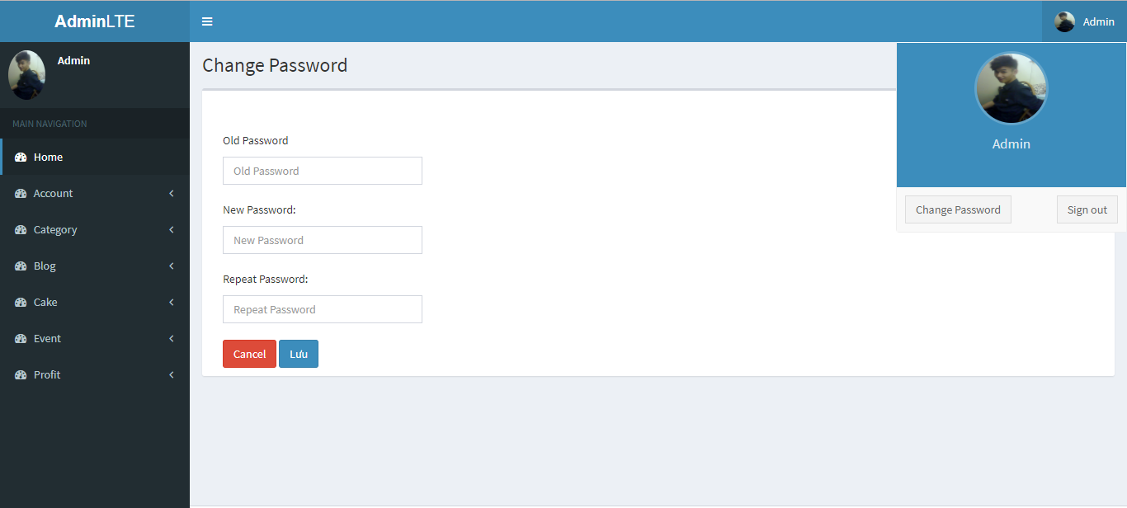

**Figure 2-19: Change password Screen**

### Account

#### Manage Account

To lock/unlock a account. Admin do the step below:

Step 1: Go to Admin page, Click on “Account”. Then click on manage account. System return list account.

Step 2: Choose account and click on lock/unlock icon button to lock/unlock account.

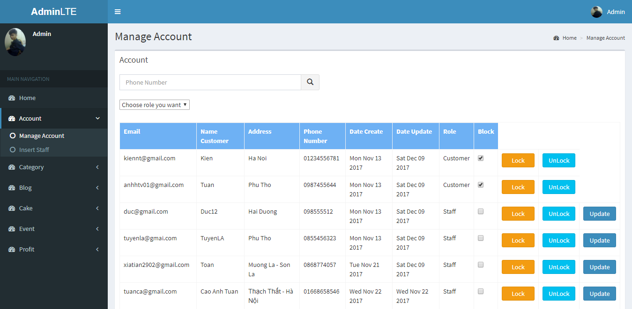

**Figure 2-20: Manage Account Screen**

To update a staff profile. Admin do the step below:

Step 1: Go to Admin page, Click on “Account”. Then click on manage account. System return list account.

Step 2: Choose staff account and click update icon button to update account. Admin will go to update staff profile page.

Step 3: Fill the form and click save to update staff profile or click cancel to cancel the update

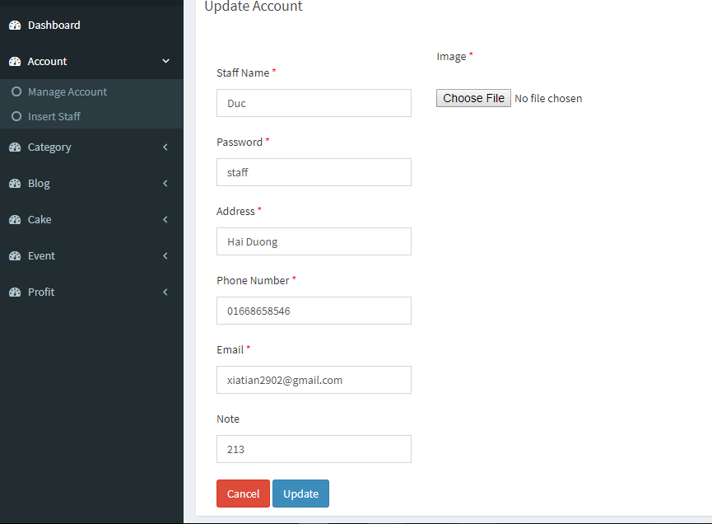

**Figure 2-21: Update Account Staff Screen**

#### Insert Staff

Admin can add a new staff. Admin do the step below:

Step 1: Go to Admin page, Click on “Account”. Then click on insert staff. System return a form.

Step 2: Fill the form and click add to add to add new staff account or click cancel to cancel.

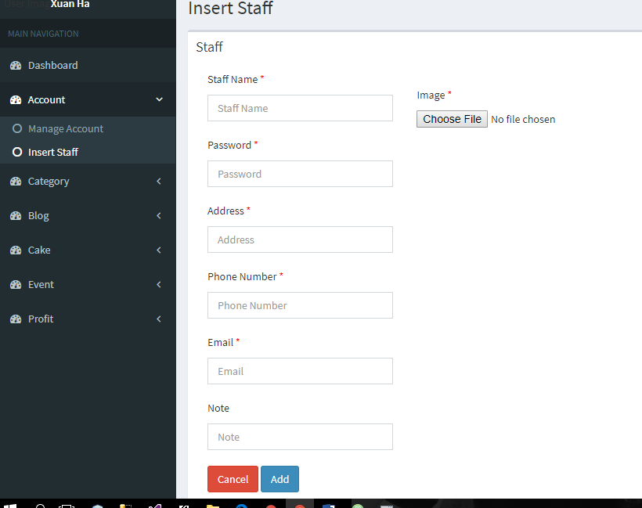

**Figure 2-22: Add Account Staff Screen**

### Category

#### Manage category

To lock/unlock a category. Admin do the step below:

Step 1: Go to Admin page, Click on “Category”. Then click on manage category. System return list category.

Step 2: Choose account and click on lock/unlock icon button to lock/unlock category.

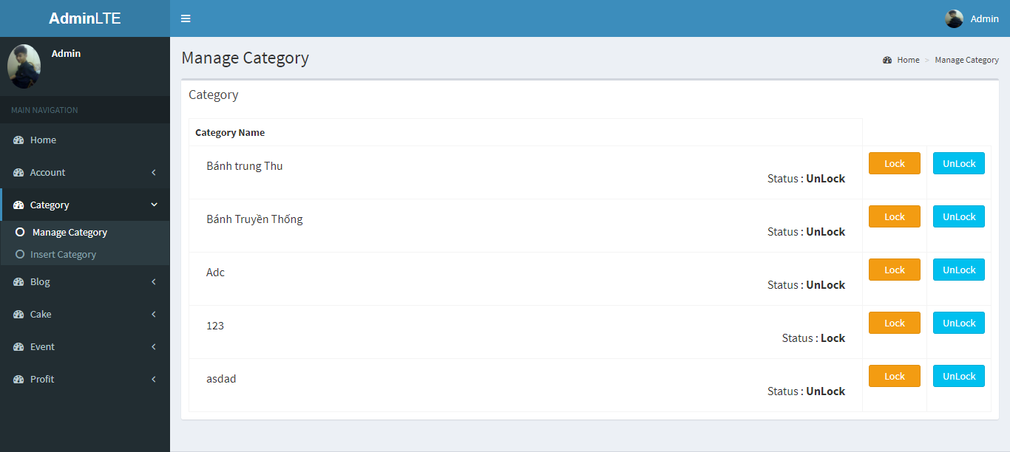

**Figure 2-23: Manage Category Screen**

#### Insert Category

To insert category. Admin do the step below:

Step 1: Go to Admin page, Click on “Category”. Then click on insert category. System return a form.

Step 2: Fill the form and click add to add to add new category or click cancel to cancel.

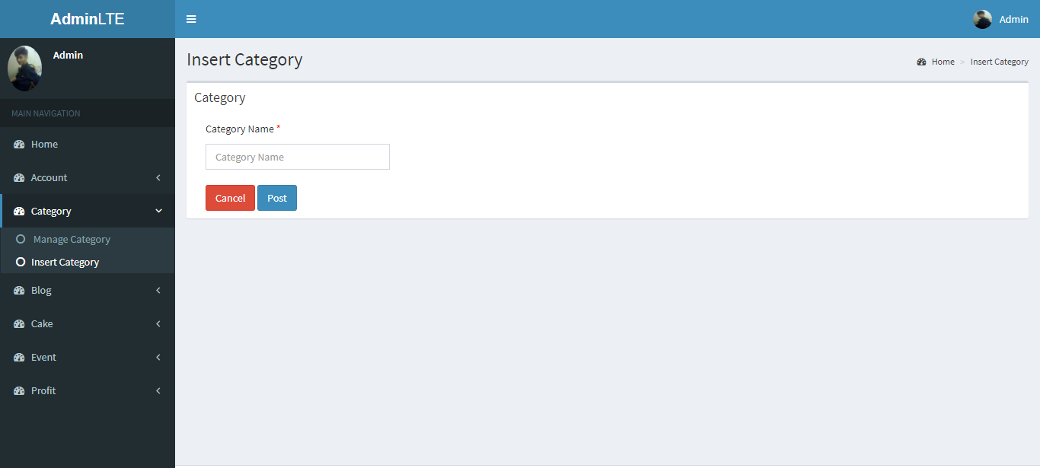

**Figure 2-24: Add Category Screen**

### Blog

#### Manage Blog

To lock/unlock a blog. Admin do the step below:

Step 1: Go to Admin page, Click on “Blog”. Then click on manage blog. System return list blog.

Step 2: Choose blog and click on lock/unlock icon button to lock/unlock blog.

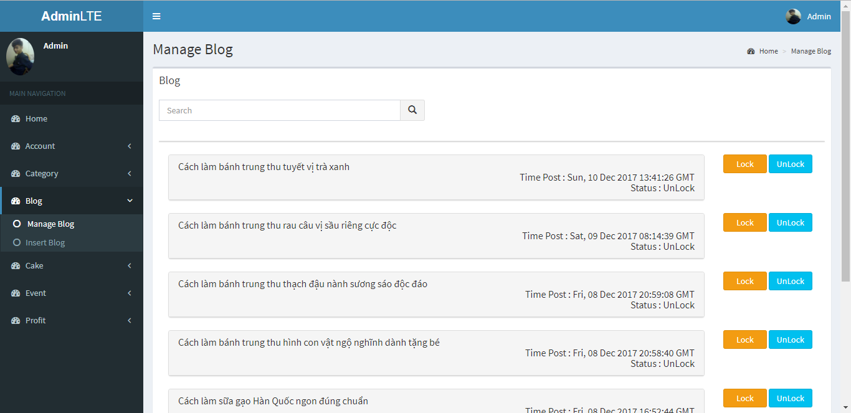

**Figure 2-25: Manage Blog Screen**

Admin can view detail of a blog by click on them to view detail

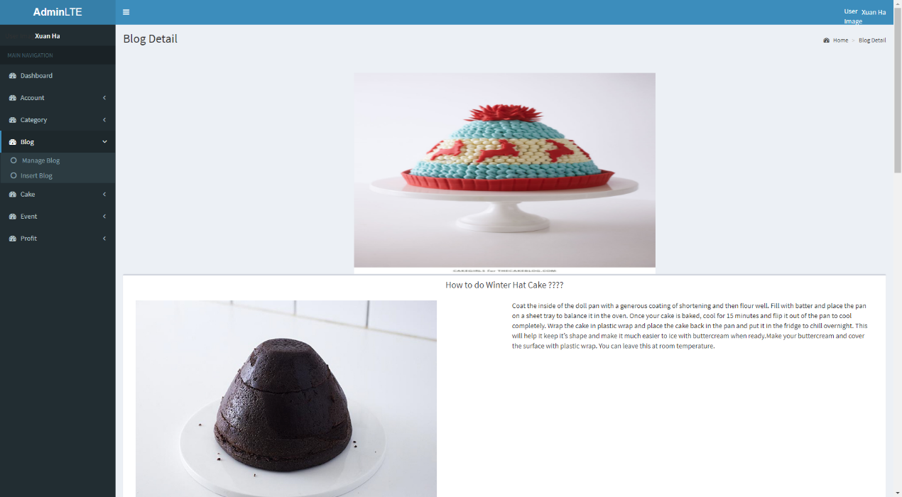

**Figure 2-26: Blog detail Screen**

#### Insert Blog

To insert blog. Admin do the step below:

Step 1: Go to Admin page, Click on “Blog”. Then click on insert blog. System return a form.

Step 2: Fill the form and click add to add to add new blog or click cancel to cancel.

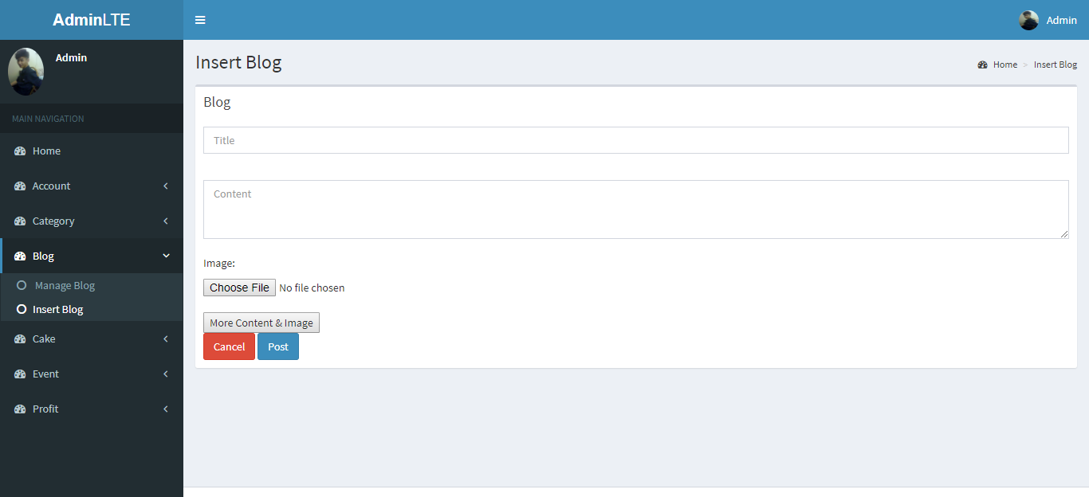

**Figure 2-27: Inserrt Blog Screen**

### Cake

#### Manage Cake

To lock/unlock a cake. Admin do the step below:

Step 1: Go to Admin page, Click on “Cake”. Then click on manage cake. System return list cake.

Step 2: Choose cake and click on lock/unlock icon button to lock/unlock cake.

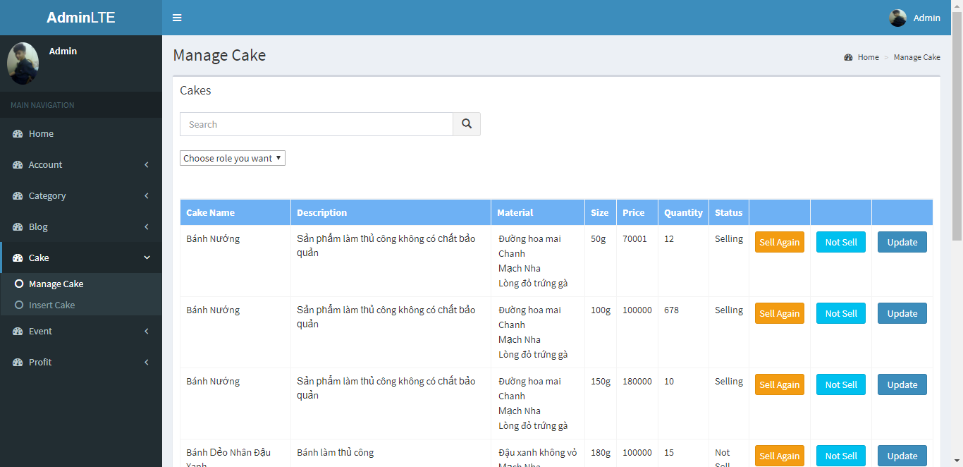

**Figure 2-28: Manage Cake Screen**

To update a cake. Admin do the step below:

Step 1: Go to Admin page, Click on “Cake”. Then click on manage cake. System return list cake.

Step 2: Choose cake and click update icon button to update cake. Admin will go to update Cake page.

Step 3: Fill the form and click save to update ake or click cancel to cancel the update

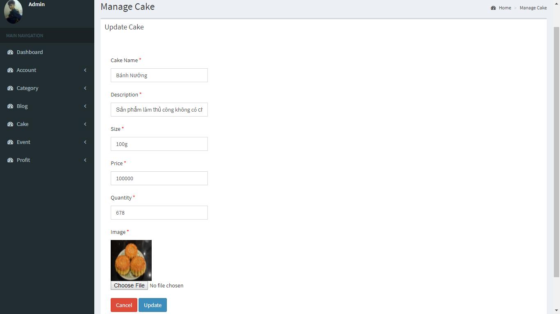

**Figure 2-29: Update Cake Screen**

#### Insert Cake

To insert cake. Admin do the step below:

Step 1: Go to Admin page, Click on “Cake”. Then click on insert cake. System return a form.

Step 2: Fill the form and click add to add to add new cake or click cancel to cancel.

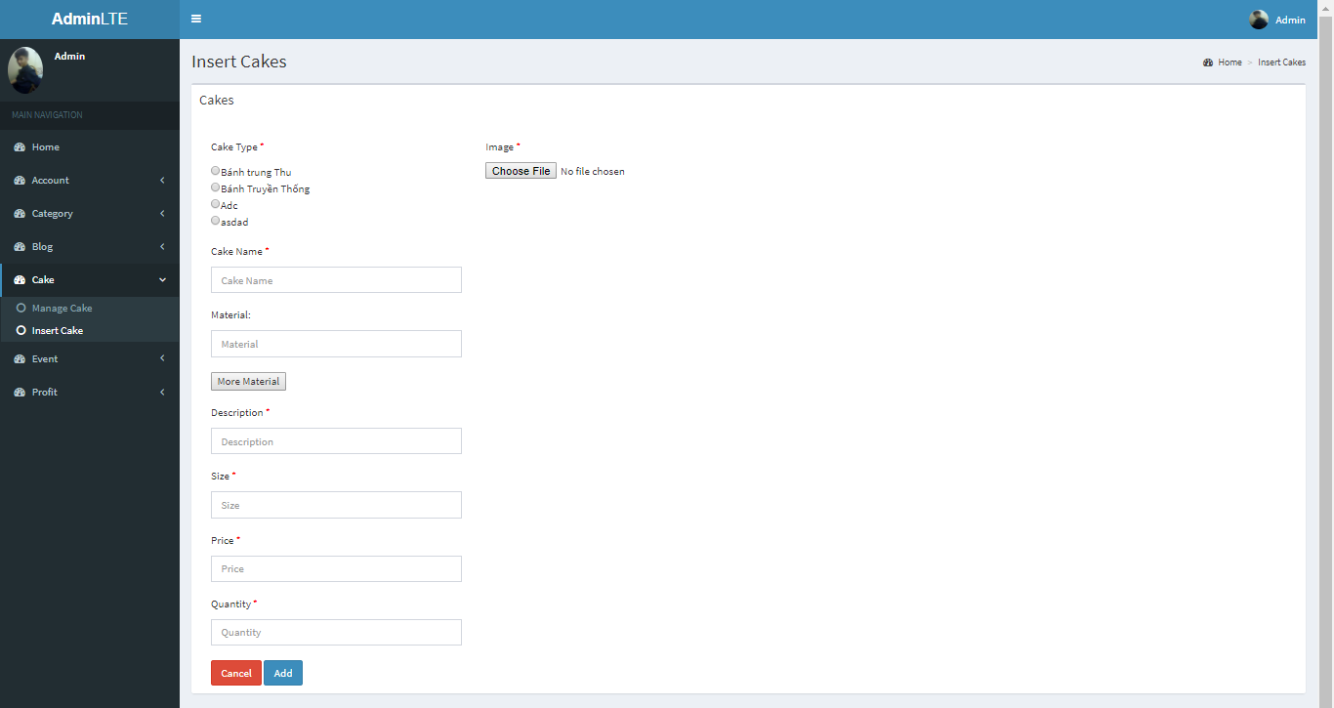

**Figure 2-30: Insert Cake Screen**

### Event

#### Manage Event

To lock/unlock a event. Admin do the step below:

Step 1: Go to Admin page, Click on “Event”. Then click on manage event. System return list event.

Step 2: Choose event and click on lock/unlock icon button to lock/unlock cake.

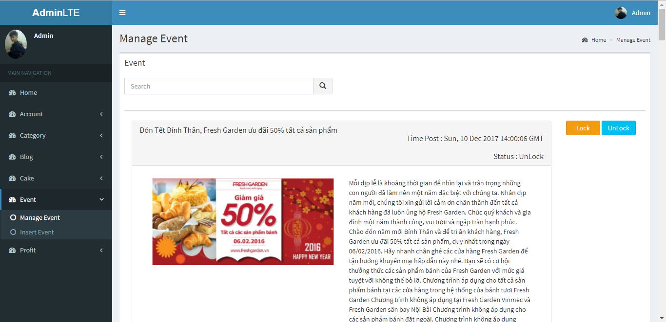

**Figure 2-31: Manage Event Screen**

#### Insert Event

To insert event. Admin do the step below:

Step 1: Go to Admin page, Click on “Event”. Then click on insert event. System return a form.

Step 2: Fill the form and click add to add to add new event or click cancel to cancel.

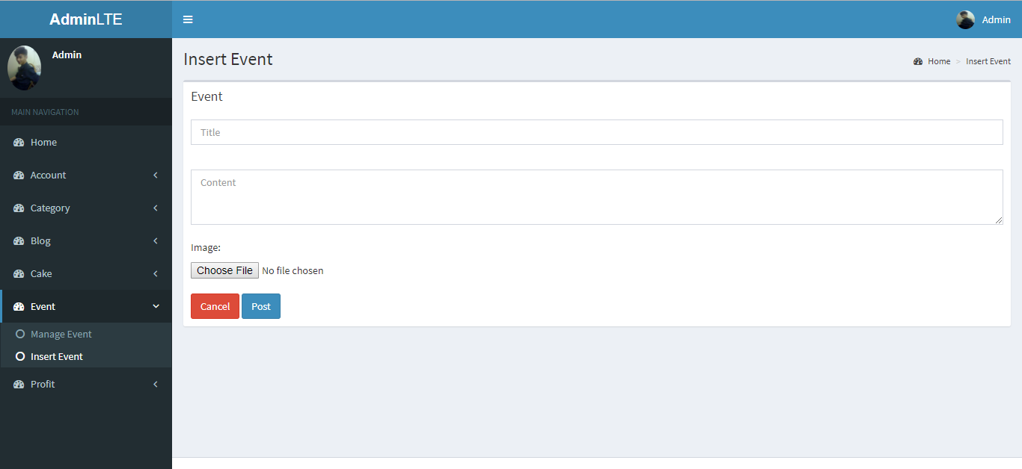

**Figure 2-32: Insert Event Screen**

### Profit

#### Manage Bill

To Confirm/Unconfirm a bill. Admin do the step below:

Step 1: Go to Admin page, Click on “Profit”. Then click on manage bill. System return list Bill.

Step 2: Choose bill and click on Confirm/Unconfirm icon button to Confirm/Unconfirm bill.

Admin can search Bill by date with search bar

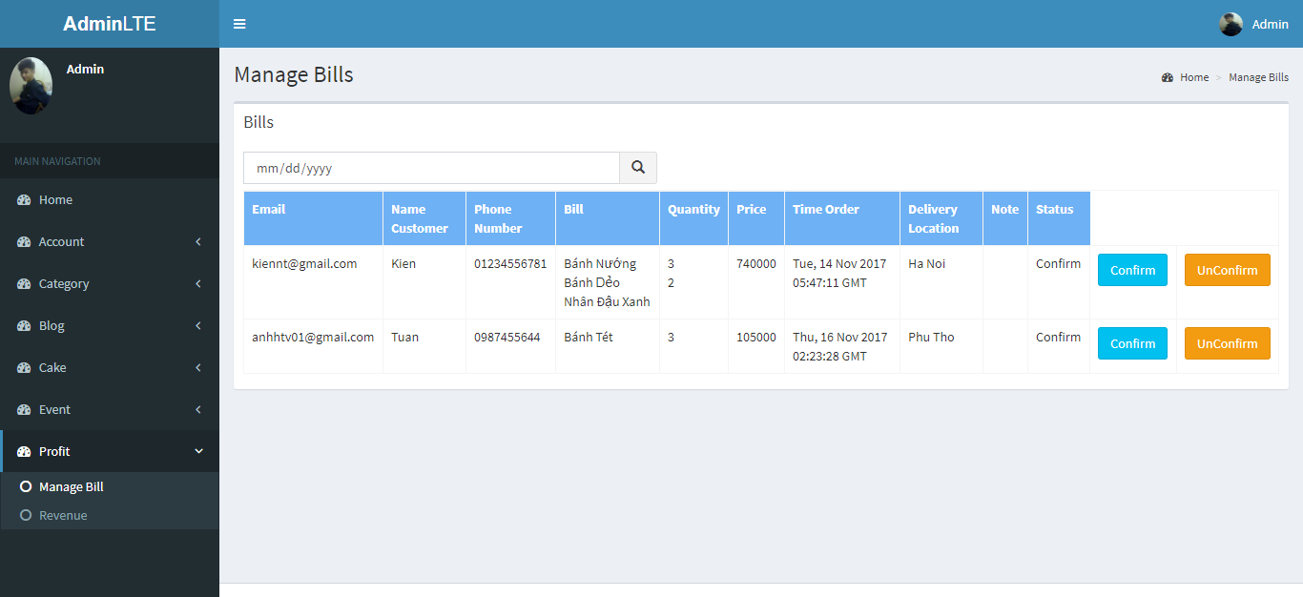

**Figure 2-33: Manage Bill Screen**

#### Revenue

Admin can view revenue of the store by date, month, quarter, years.

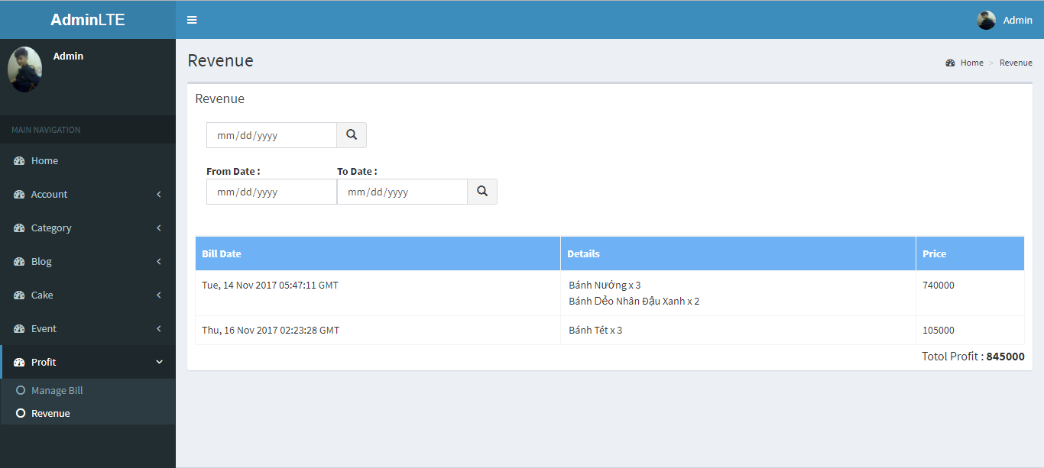

**Figure 2-34: Revenue Screen**

## Staff

### Sign in

To login staff account, the users do the steps below:

Step 1: Open browser and enter to the address bar: <http://catbakery.herokuapp.com/loginStaff/>.

Step 2: User enter username and password

Step 3: Click on Sign in button

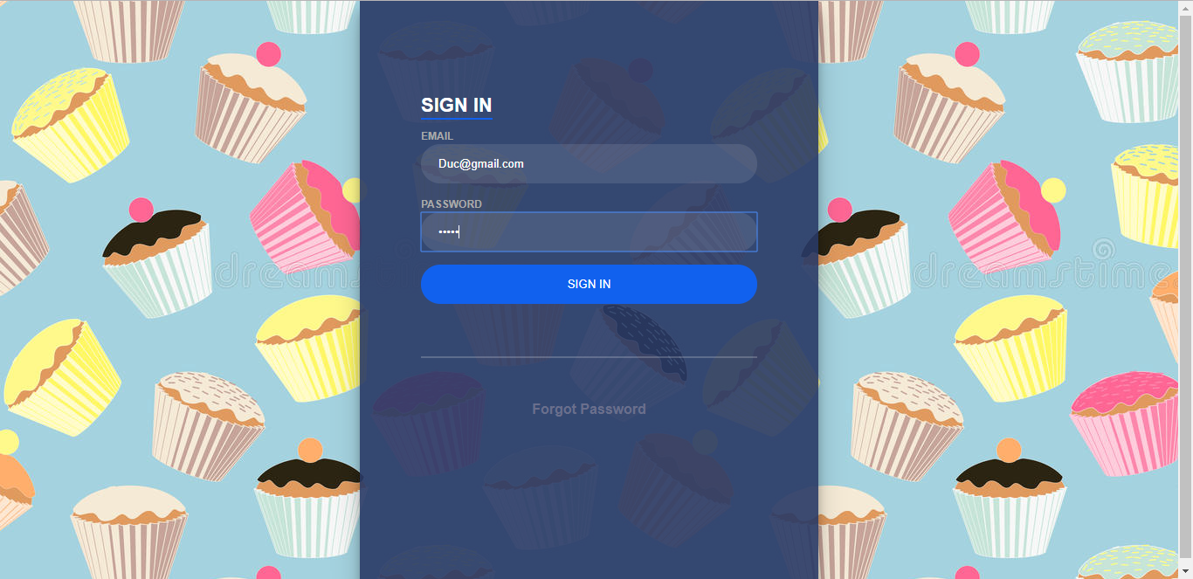

### Forgot Password

If forgot password , the users do the steps below:

Step 1: Open browser and enter to the address bar: <http://catbakery.herokuapp.com/loginStaff/>.

Step 2: Click to the Forgot password button below sign in button.

Step 3: Enter the email of staff

Step 4: System will sent to your mail a new password with random character



### Manage Cake

Staff can view all the cake in store and can search cake by category and name

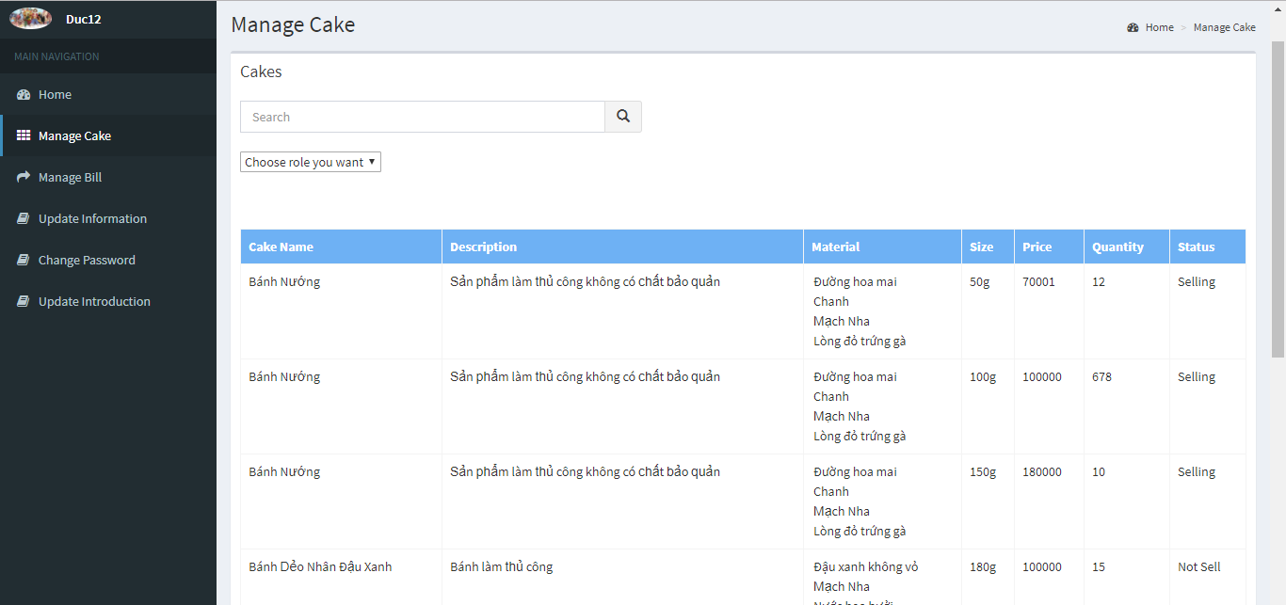

### Manage Bill

To Confirm/Unconfirm a bill. Staff do the step below:

Step 1: Go to Staff page, Click on “Manage Bill”. System return list Bill.

Step 2: Choose bill and click on Confirm/Unconfirm icon button to Confirm/Unconfirm bill.

Staff can search Bill by date with search bar

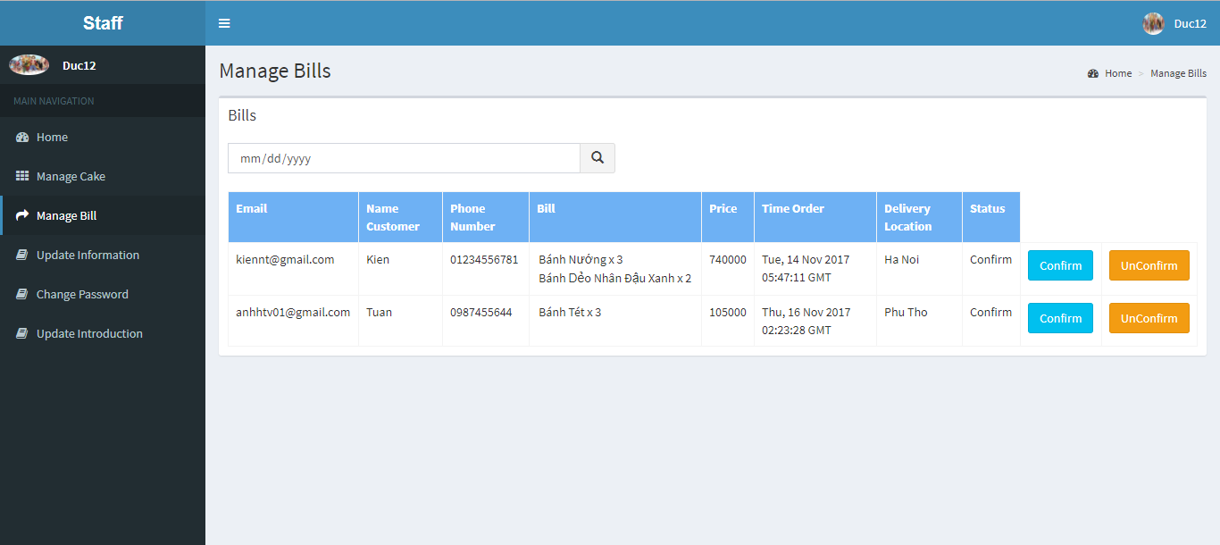

### Update information

To update profile. Staff do the step below:

Step 1: Go to Staff page, Click on “Update Information”.

Step 3: Fill the form and click save to update profile or click cancel to cancel the update